Wellness
Wellness involves being aware of ourselves as whole people, including a sense of balance and comfort. It is a sense that things are going well for us today, and can continue to go well for us tomorrow. It is a sense that we have meaningful relationships and a sense of meaning and purpose. Although we may have setbacks, or experience stress, we are resilient and we have strength, material resources, and the support of others to survive and thrive. Stress, addictions, illness, and traumatic experiences impact wellness and balance. At the Institute, we believe that helping people improve their personal wellness, as they define it, is critical. Wellness incorporates all of the eight dimensions shown on the cover and back of this booklet. Each dimension of wellness can affect our overall quality of life, because wellness directly relates to how long we live (longevity) and how well we live (quality of life). When we look at the eight-dimension model, our attention is drawn to the idea that all eight dimensions are connected. We all know how much they are connected in our lives. When we feel financially stressed (e.g., increasing debt), we experience emotional stress (anxiety), sometimes leading to physical problems (illness), less effectiveness at work (occupational), and maybe even questioning our own meaning and purpose in life (spiritual). When we are not working (occupational), we lose some of our opportunities to interact with others (social), cannot get the quality foods and medical care we need to stay well (physical), and may need to move to a place that feels less safe and secure (environmental). Stress, addiction, trauma, disappointment, and loss can impact our wellness and the balance in our lives. It seems important to balance work with play and rest, to balance time out for recuperation and recovery with living our lives fully and productively, and to balance the desire for rapid change with the known effectiveness of slow changes to build good habits.
Habits
Habits are key for wellness. Our habits affect what we do, how we feel, how we work, how we fuel our minds and bodies and how we spend or save money. Habits become ingrained, and we have to work consciously to maintain or establish good habits that contribute to our wellness, our valued roles, and our personal goals. Some habits (excessive alcohol, harmful drugs or chemicals, consumption of energy drinks, sugar and fat laden foods) can have immediate or long-term negative effects on physical, mental, and social well-being. Another part of wellness is our valued roles such as friend, worker, volunteer, student, colleague, parent, spouse, and community member. These roles provide an identity, drive our daily activities, and ignite our passions. Wellness involves a sense of empowerment. Each day we wake up we can make choices. Empowerment goes hand-in-hand with taking personal responsibility for our day to day choices and our lives. We hope this guide will help you think about your own wellness—what you already do now (your daily routines, habits, and valued life roles and activities), what else you can do or can learn to do, and what type of supports you need to focus on your wellness and balance. One of the things many people find helpful is to look at their own wellness in each dimension. For each of the eight dimensions that follow, record your strengths and your thoughts about areas you may want to change or improve. This wellness booklet can offer some insights to determine things you are doing well and things you may want to start or stop doing. Please use this booklet yourself and consider sharing with co-workers or support group members so you can review, plan, and grow together. We hope this is helpful. We wish you a successful wellness journey!

Wellness is not the absence of disease, illness, and stress but the presence of:
- Purpose in life
- Active involvement in satisfying work and play
- Joyful relationships
- A healthy body and living environment
- Happiness
Wellness is a conscious, deliberate process that requires being aware of and making choices for a more satisfying lifestyle.
A wellness lifestyle includes a self-defined balance of health habits such as sleep and rest, eating well, productivity, participation in meaningful activity, and contact with supporters.
Wellness is multi-dimensional: physical, spiritual, social, emotional, intellectual, occupational, environmental, and financial.

Physical Wellness involves the maintenance of a healthy body, good physical health habits, good nutrition and exercise, and obtaining appropriate health care. Strengths These are the things I do well – my daily routines, habits, and valued life activities that build and maintain my physical wellness:

Physical Wellness Self-Assessment
I almost always do this = 2 points
Sometimes/occasionally = 1 point
I very seldom do this = 0 points

1. ___ I exercise aerobically (vigorous, continuous exercise) for 20 to 30 minutes at least three times per week.
2. ___ I eat fresh fruits, vegetables, and whole grains every day.
3. ___ I avoid tobacco products.
4. ___ I wear a seat belt while riding in or driving a car.
5. ___ I avoid drinking caffeinated and sugary beverages.
6. ___ I get an adequate amount of sleep (7-9 hours/night).
7. ___ I keep up with my annual physical, dental checkups, immunizations, and self-exams.
8. ___ I maintain a reasonable weight for my age and height.
9. ___ I brush my teeth at least twice daily, and floss at least once daily.
10. ___ I use stress management techniques that help me to stay calm and relaxed.

Physical Wellness - things I would like to do

***
Intellectual Wellness involves lifelong learning, application of knowledge learned, and sharing knowledge.
Strengths These are the things I do well – my daily routines, habits, and valued life activities that build and maintain my intellectual wellness:

Intellectual Wellness Self-Assessment
I almost always do this = 2 points
Sometimes/occasionally = 1 point
I very seldom do this = 0 points

1. ___ I make an effort to learn new things.
2. ___ I try to keep on top of current affairs—locally, nationally, and internationally.
3. ___ I listen to lectures, plays, and musical performances—in person or online.
4. ___ I do creative and stimulating mental activities/games.
5. ___ I read daily, whether that be the newspaper, the internet, magazines, or books from my local bookstore or library.
6. ___ I practice something every week to improve my skills and use my gifts, such as crafts, cooking, music, or sports.
7. ___ I try to see more than one side of an issue, especially for things that are controversial.
8. ___ I engage in intellectual discussions.
9. ___ I look up things that I don’t know.
10. ___ I ask questions to learn from others.

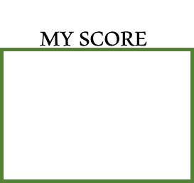

Intellectual Wellness- things I would like to do

***
Environmental Wellness involves being and feeling physically safe, in safe and clean surroundings, and being able to access clean air, food, and water. Includes both our microenvironment (the places where we live, learn, work, etc.) and our macro-environment (our communities, country, and whole planet).
Strengths
These are the things I do well – my daily routines, habits, and valued life activities that build and maintain my environmental wellness:

Environmental Wellness Self-Assessment
I almost always do this = 2 points
Sometimes/occasionally = 1 point
I very seldom do this = 0 points
1. ___ I regularly clean my living and work environment.
2. ___ I make maximal use of natural light, fresh air, and live plants.
3. ___ I discard garbage regularly, clean spoiled foods out of the refrigerator, and stay on top of any pet odors.
4. ___ I tidy my home and work spaces in order to prevent clutter and stay organized.
5. ___ I conserve energy (fuel, electricity, water, etc.) in my home, my car, and elsewhere.
6. ___ I recycle (glass, paper, plastic, etc.).
7. ___ I do not litter.
8. ___ I purchase recycled items when possible.
9. ___ I set aside time to enjoy nature.
10. ___ I set aside time to reflect and/or practice mindfulness.
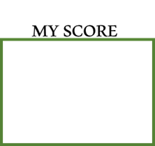

Environmental Wellness- things I would like to do

***
Spiritual Wellness involves having meaning and purpose and a sense of balance and peace.
Strengths
These are the things I do well – my daily routines, habits, and valued life activities that build and maintain my spiritual wellness:

Spiritual Wellness Self-Assessment
I almost always do this = 2 points
Sometimes/occasionally = 1 point
I very seldom do this = 0 points

1. ___ I can name my own personal values and describe my beliefs about life.
2. ___ I make conscious choices about my daily actions based on my personal values.
3. ___ When I get depressed or frustrated, I draw on my beliefs and values to give me direction.
4. ___ I use prayer, meditation, and/or quiet personal reflection regularly in my life.
5. ___ Life is meaningful for me, and I feel a purpose in life.
6. ___ I try to learn about others' beliefs and values, especially those that different from my own.
7. ___ I have a strong sense of optimism and faith in the future.
8. ___ I use my thoughts and attitudes in life-affirming ways.
9. ___ I appreciate the natural forces that exist in the universe.
10. ___ I feel gratitude for the good things in my life. My
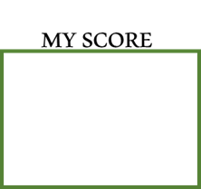

Spiritual Wellness- things I would like to do

***
Social Wellness involves having relationships with friends, family, and the community, and having an interest in and concern for the needs of others and humankind.
Strengths These are the things I do well – my daily routines, habits, and valued life activities that build and maintain my social wellness:

Social Wellness Self-Assessment
I almost always do this = 2 points
Sometimes/occasionally = 1 point
I very seldom do this = 0 points

1. ___ I have a network of friends and/or family.
2. ___ I contribute time and/or money to social and community projects or causes.
3. ___ I regularly spend time with people I like.
4. ___ I balance my own needs with the needs of others.
5. ___ I am a compassionate person and try to help others when I can.
6. ___ I have a sense of belonging within my community.
7. ___ I feel comfortable meeting new people.
8. ___ I can give and receive compliments graciously.
9. ___ I communicate with and get along with a wide variety of people.
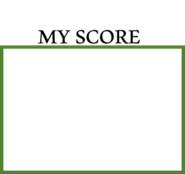
10. ___ I am interested in others, including those with backgrounds that are different from my own.

Social Wellness- things I would like to do

***

Emotional Wellness involves the ability to express feelings, enjoy life, adjust to emotional challenges, and cope with stress and traumatic life experiences.
Strengths These are the things I do well – my daily routines, habits, and valued life activities that build and maintain my emotional wellness:

Emotional Wellness Self-Assessment
I almost always do this = 2 points
Sometimes/occasionally = 1 point
I very seldom do this = 0 points

1. ___ I accept responsibility for my actions.
2. ___ I see challenges and change as opportunities for growth.
3. ___ I believe that I have considerable control over my life.
4. ___ I am able to laugh at life and myself.
5. ___ I feel good about myself.
6. ___ I am able to appropriately cope with stress and tension.
7. ___ I make time for leisure pursuits.
8. ___ I am able to recognize my personal shortcomings and learn from my mistakes.
9. ___ I am able to recognize and express my feelings.
10. ___ I enjoy each day.
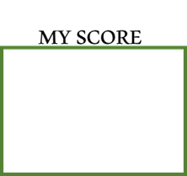

Emotional Wellness- things I would like to do

***
Financial Wellness involves the ability to have financial resources to meet practical needs, and a sense of control and knowledge about personal finances.
Strengths These are the things I do well – my daily routines, habits, and valued life activities that build and maintain my financial wellness:

Financial Wellness Self-Assessment
I almost always do this = 2 points
Sometimes/occasionally = 1 point
I very seldom do this = 0 points
1. ___ I have a good handle on my financial status.
2. ___ I have money on hand to meet my current expenses.
3. ___ I understand the issues of balancing my wants and needs, and balancing saving and spending.
4. ___ I balance my checkbook and audit my credit card statements.
5. ___ I have money on hand or available credit to deal with moderate unexpected life expenses such as a needed car repair, broken glasses, or an emergency trip to see a sick relative ($100-$1000).
6. ___ I pay my bills and file my taxes on time, and rarely or never get overdue notices, over-limit fees, or bounced check notices.
7. ___ I check my credit reports at least once a year.
8. ___ My savings are on track with my life goals, such as home ownership, educating my children, or retirement.
9. ___ I do not worry about money.
10. ___ I have people I can turn to for good help with financial matters.
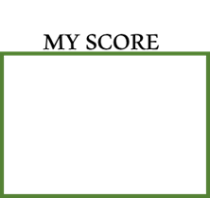

Financial Wellness things I would like to do

***
Occupational Wellness involves participating in activities that provide meaning and purpose, including employment.

Strengths
These are the things I do well – my daily routines, habits, and valued life activities that build and maintain my occupational wellness:

Occupational Wellness Self-Assessment – Select and complete 1 of the 3 Self-Assessments, depending on whether you are currently employed, looking for work, or not working.
I almost always do this = 2 points
Sometimes/occasionally = 1 point
I very seldom do this = 0 points
1. ___ I am happy with my career choice.
2. ___ I am productive on most days at work.
3. ___ I look forward to work.
4. ___ My job responsibilities/duties are consistent with my values.
5. ___ The payoffs and advantages in my choice of career/field are consistent with my values.
6. ___ I am happy with the balance between my work time and my leisure time.
7. ___ I am happy with the amount of control I have in my work.
8. ___ My work gives me personal satisfaction and stimulation.
9. ___ I am happy with the professional and personal growth that is provided by my job.
10. ___ My job allows me to make good use of my talents

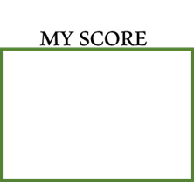

I am Looking for Work (I plan to enter or return to the workforce or I hope to increase my work hours)
I almost always do this = 2 points
Sometimes/occasionally = 1 point
I very seldom do this = 0 points
1. ___ I am actively pursuing work and/or training.
2. ___ I have considered my options regarding career change, getting additional education, self-employment, etc.
3. ___ I am pursuing an organized job search, keeping good records, and doing something towards my job search every day.
4. ___ I use online resources to look for work, update skills, and network with others regarding my job search.
5. ___ I assertively market myself through personal networking.
6. ___ I confidently describe my skills and strengths as a worker.
7. ___ I have reached out to former colleagues, teachers, and other resources associated with my field or professional group.
8. ___ I am aware of and use general community resources for people seeking work.
9. ___ While I am waiting to get a job, I use my time productively to maintain my skills, support my community, etc.
10. ___ I am hopeful in my job search.
I am Not Working due to Retirement, being a Full-Time Student, Family Caregiving Responsibilities, or Choice
I almost always do this = 2 points
Sometimes/occasionally = 1 point
I very seldom do this = 0 points
1. ___ I am happy with how I spend my time.
2. ___ I have plans for things that I want to do.
3. ___ I do things with other people often enough not to feel isolated.
4. ___ I use my time in a way that gives me meaning and purpose.
5. ___ I make good use of my strengths and experiences in the things I am doing each week.
6. ___ My weekly activities are consistent with my values and interests.
7. ___ I control how I spend my time.
8. ___ I volunteer in the community, or have considered volunteering.
9. ___ I feel productive every week.
10. ___ I look forward to my daily and weekly activities.

Occupational Wellness- things I would like to do

***

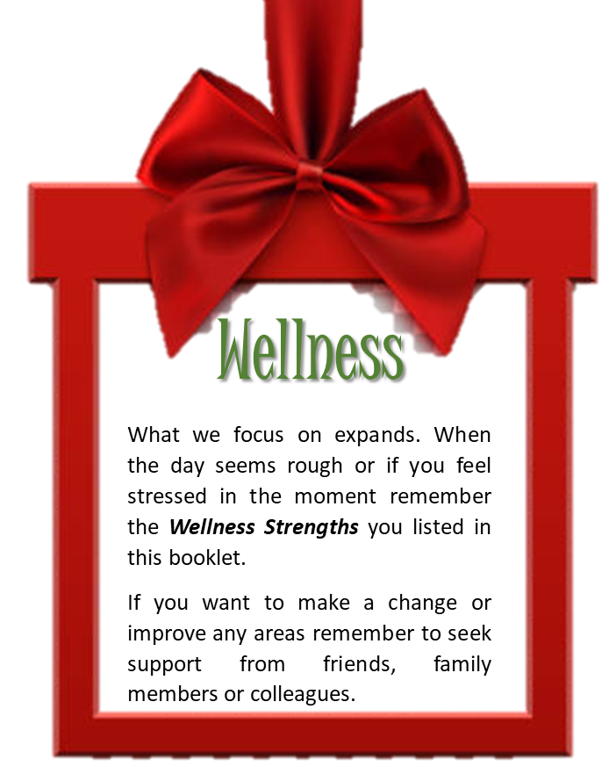

Wellness is a conscious, deliberate process that requires being aware of and making choices for a more satisfying lifestyle.

